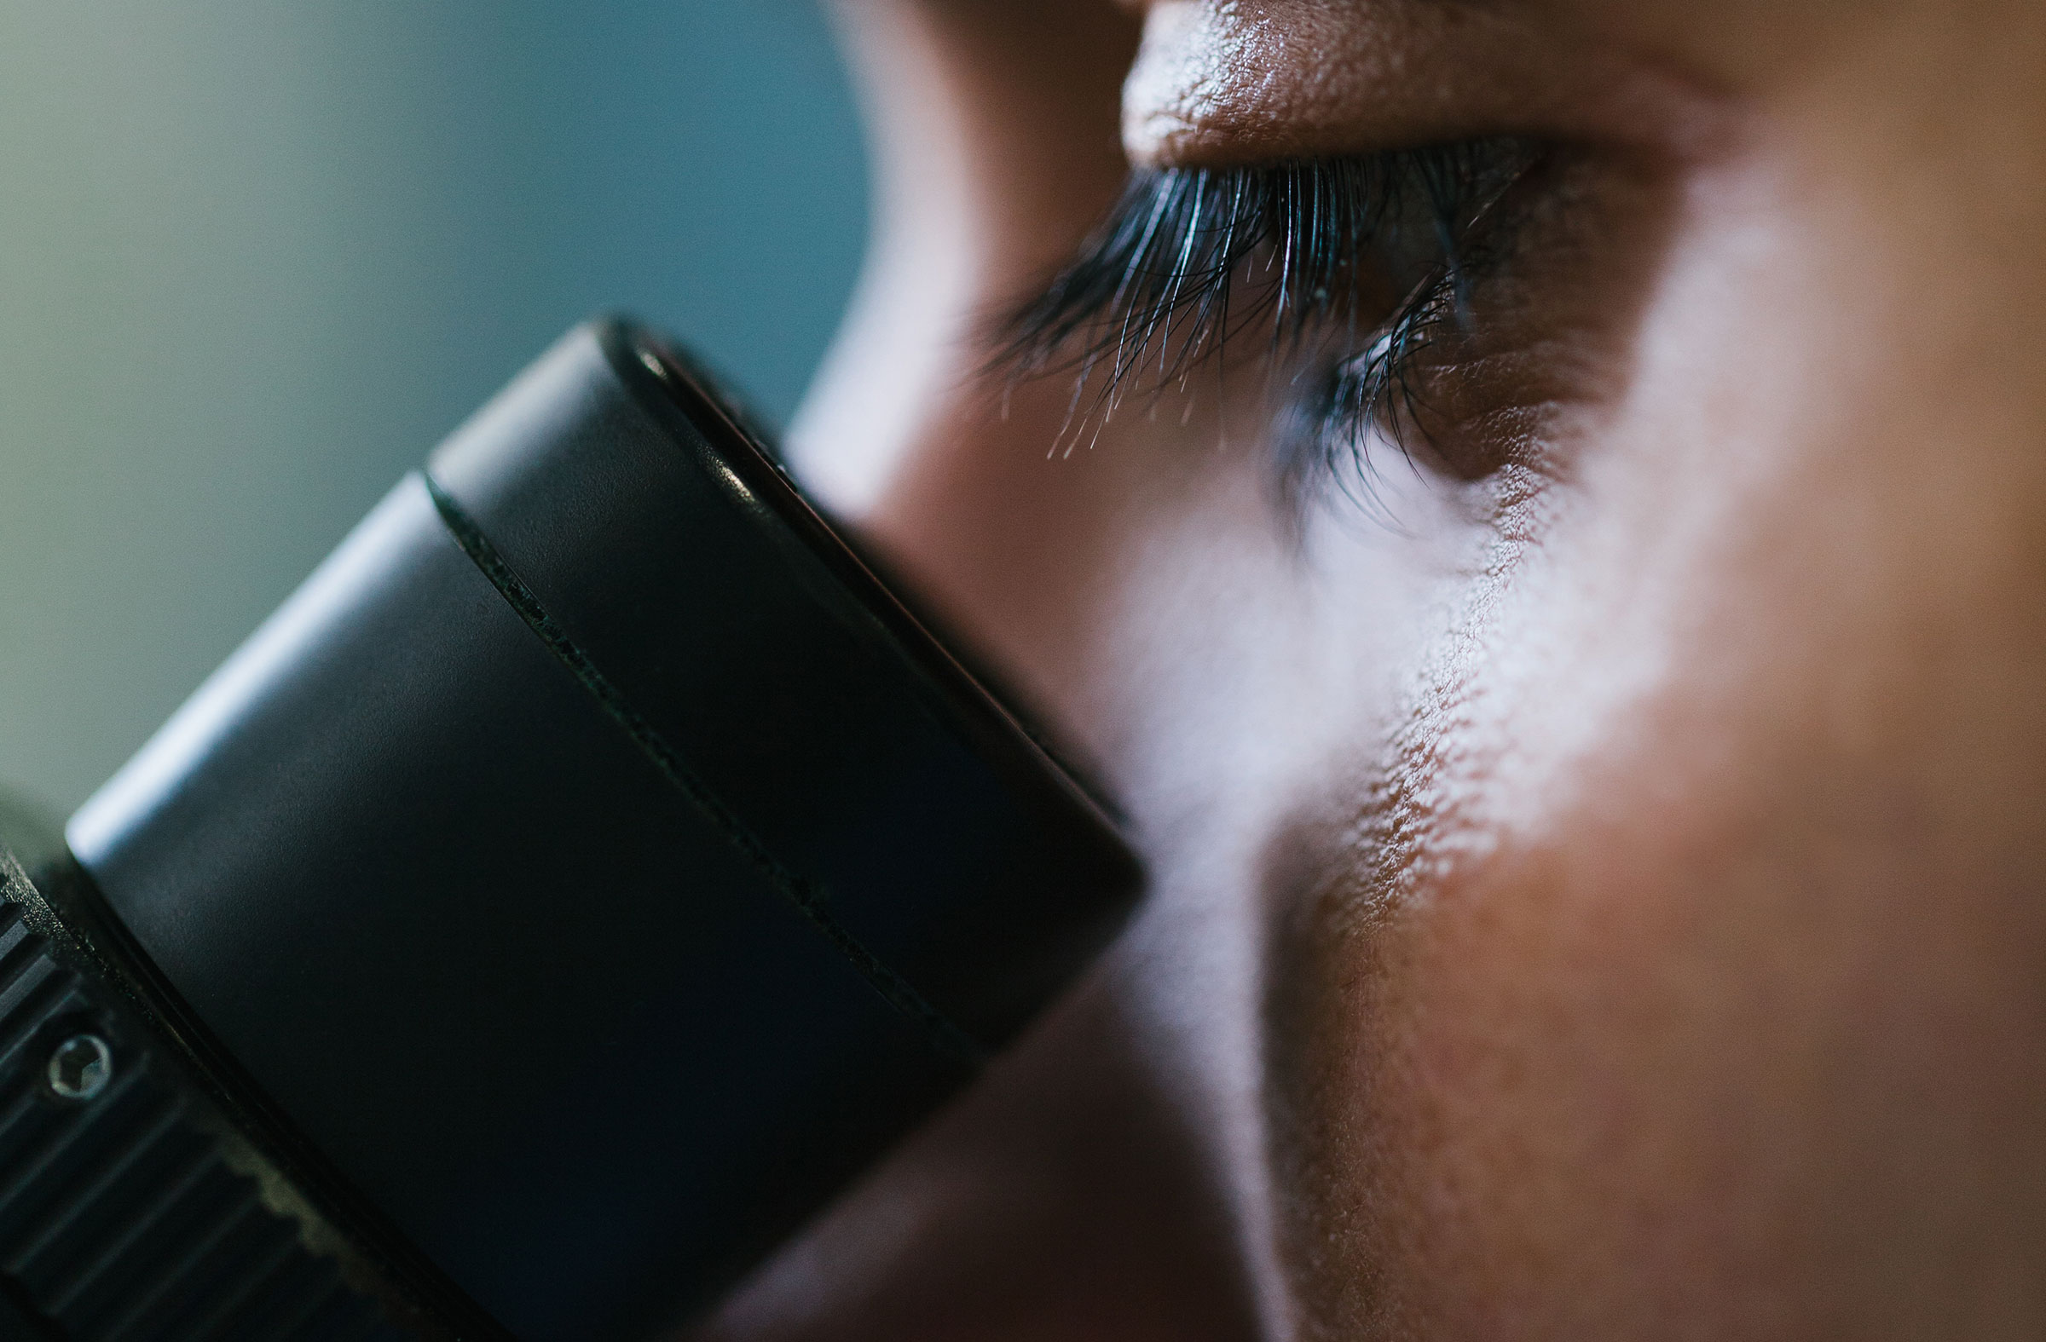

# Dr. Jane Doe-Smith Research Director Heart and Stroke Foundation of Canada Special Guest Lecturer

155 College St.

Dalla Lana School of Public Health Auditorium, HS610

RSVP[: http://dlsphjanedoesmith.eventbrite.ca](http://dlsphjanedoesmith.eventbrite.ca/)

# Fundraising for Health: The Rewards and Challenges

## Please join us for this engaging lecture and discussion. This event is free and open to all.

# Sept. 25 5–8pm