Dear _________________________,

You are being contacted because you signed up to be a part of a research study. In this study, the researchers are collecting data and blood samples from a group of UofT students to look for proteins in the blood that indicate that a person has had previous exposure to COVID-19 virus.

Along with this letter, you are receiving a home-based blood collection kit, pre-labeled with a unique identification number, as well as return labels and leakproof packaging following the guidelines for shipment of Biological Substances. Please see the schedule below for drop off times and locations nearest to your campus residence or course locations. If these are difficult to reach, please email the study coordinator to arrange courier pick up.

The home-based blood collection kit contains:

1. Biohazard specimen transport bag

2. Antiseptic isopropyl alcohol pad

3. 2 Lancets (*default = pink)

4. Blood collection tube

5. Gauze

6. Band aid

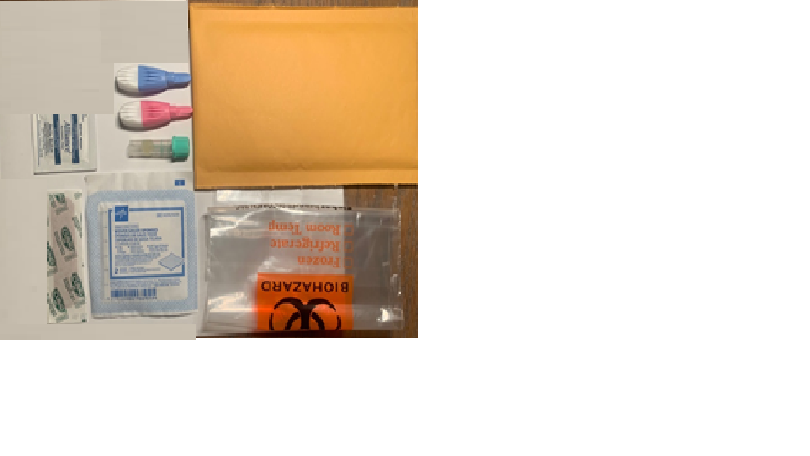

**Instructions:**

1. First, please review a short video entitled “How to take your COVID-19 capillary blood sample” (<https://drive.google.com/file/d/1uH7syk3asGDcesETIJe32PITQ1sx8sqJ/view?usp=sharing>) about self-collection of blood samples. Also see a pictorial view of the collection steps at the end of the document.
2. Read all the instructions for capillary (finger prick) blood sample collection. Although self-collection of blood is strongly encouraged, venipuncture is available if you find that you cannot perform self-collection at any or all time points.
3. To ensure the integrity of the blood sample and delivery to the laboratories on the day of collection, please collect blood specimens a weekday between Monday through Thursday, avoiding any Statutory Holidays (Tuesdays if Monday is a Statutory Holiday).
4. Ensure that the study ID on the tube matches the label on the requisition form.
5. Ensure your kit has all of the items listed above and set it on a clean desk or table.
6. To facilitate collection, increase your heart rate by doing some exercise (e.g. going up the stairs) and activate the circulation in your hands by shaking them below your heart level and flexing your fingers.
7. Wash your hands with soap and warm water (the warm temperature will facilitate the blood collection). Dry your hands. You can also rub your hands together to warm them up.
8. At your collection station, keep your hand below the level of your heart. Disinfect your middle or ring finger (non-dominant hand) with the alcohol pad.
9. In the collection kit, we provide the pink lancets (default choice) that enable a medium flow. Alternative lancets (blue lancets) are available to those who need or prefer them. The blue lancets also have a retractable blade that has an increased puncture depth, resulting in a higher blood flow (please note that they may also be more painful to use).
10. Remove the cap from the lancet and press firmly against the skin of your finger. Aim to be close to, but not at the tip, and slightly off-center (see the pictures at the end of this document. The lancet is pressure activated; it will pierce the skin at a fixed depth and then the blade will retract, and you can begin your collection.
11. Use the gauze to wipe away the first drop of blood.
12. Hold your finger over the tube and massage down from the palm to the tip of the finger to promote blood flow to fill the tube to or above the 500 μl mark has been collected. Please return your collection tube even if you have not been able to provide the full volume.
13. Replace the cap by twisting and pushing the cap downward until a snap is heard.
14. Immediately after collection, mix the sample by gently inverting the filled tube 5 to 10 times.
15. Place the tube in the biohazard bag.
16. Also place both lancets in the biohazard bag (for proper disposal).
17. Seal the biohazard bag.
18. Fold and insert the requisition form that you received into the return envelope. Also insert the biohazard bag into the return envelope and then seal the envelope.
19. Deposit the return envelope into the designated collection box for the study by 1:00 PM on the same day you collect your specimen. Refer to the schedule for campus sites to know when samples will be picked up from your location.
20. If you selected the option of having a courier pick up your sample when you registered, kindly call the courier at the number provided. Before the courier arrives, you can store the sample in a fridge.

Capillary blood collection is associated with minimal risk, including pain at the site of collection bleeding, or scarring. Rarely, person can also feel dizzy after capillary blood collection due to the person being nervous. Pain at the site of collection can be relieved with cold compress. Bleeding can be stopped by application of pressure to the blood collection site with a gauze and band aid. If bleeding is slow to stop, apply pressure to the puncture site with a sterile gauze or a cotton ball. If bleeding continues after 3 to 5 minutes of applying pressure, consult a physician. Hydration with fluids can help a person who feels dizzy. If the participant has concerns, you may contact Health & Wellness (214 College Street, 2nd Floor Phone: 416-978-8030) during business hours, Telehealth at 1-866-797-0000, or visit an urgent care center or walk-in clinic for immediate attention. These events should subsequently be reported to the study coordinator at [UofTpandemicstudy.dlsph@utoronto.ca](mailto:UofTpandemicstudy.dlsph@utoronto.ca)

The blood collected will be used only for research. The data obtained from this study will help researchers better understand the COVID-19 virus and can also provide information that is useful for planning.

The information that we collect from this research study will be kept private and your identity will not be revealed in any dissemination of study results. Your individual data will not be shared to anyone outside of the research team. Only the research coordinator will be able to see your name. Your contact information will be collected to enable us follow up with you in the context of this study and to conduct contact tracing if you get exposed to COVID-19 in coming to the drop-off location sites. Contact information will however be kept separate from data collected through the research study to maintain anonymized research data. UofT will only have access to summary data of the entire cohort combined. Your participation in this study is voluntary, and you may withdraw and ask to have your survey data deleted by notifying the study coordinator at [UofTpandemicstudy.dlsph@utoronto.ca](mailto:UofTpandemicstudy.dlsph@utoronto.ca). There will be no penalty or loss of benefits to which you are otherwise entitled.

This study will have no direct cost to you and requires minimal time. You will receive a $20 Uber Eats gift card as a token of appreciation for participating in this study for each of the three data collections (online survey and blood sample completed) for a total of $60.

If you have any questions about your rights as a research participant or have concerns about this study, please contact the Research Oversight and Compliance Office – Human Research Ethics Program, University of Toronto at [ethics.review@utoronto.ca](mailto:ethics.review@utoronto.ca) or 416-946-3273.  If you have any questions about the study, please contact the Research Coordinator at [UofTpandemicstudy.dlsph@utoronto.ca](mailto:UofTpandemicstudy.dlsph@utoronto.ca) Thank you very much for your participation.

**Pictorial Instructions for blood sample collection**

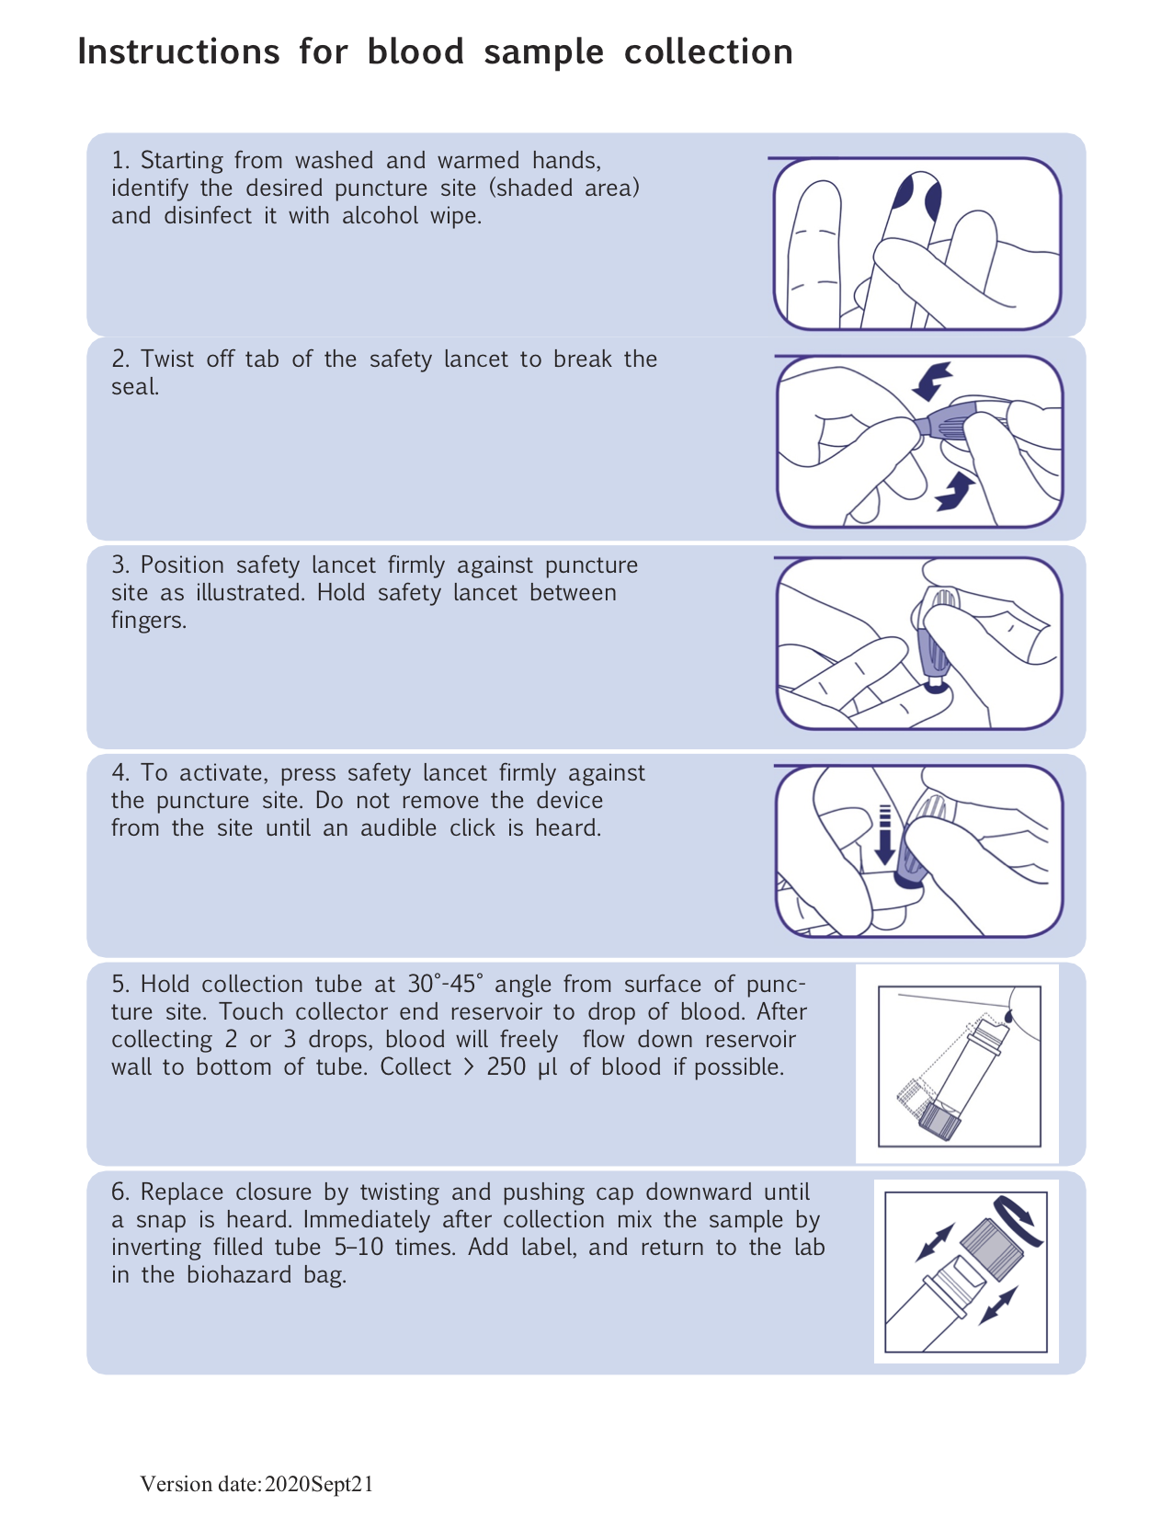

Sample Drop off Schedule

Please collect your blood sample is the same morning as assigned for your residence, and drop off the sample at designated boxes at the following locations between **10am-1pm ONLY** from December 3., 2020 until December 18, 2020.

|  |  |  |  |  |  |  |  |
| --- | --- | --- | --- | --- | --- | --- | --- |
| **Campus site** | **Drop off Location** | **Address** | **Student drop off time** | **M** | **T** | **W** | **T** |
| **St. George:** |  |  |  |  |  |  |  |
| New College | Wilson Hall Front Desk | 40 Willcocks St. M5S 1C6 | 10am-1pm | x | x |  |  |
| Innis College | Innis College Front Desk | 111 St. George Street, ON M5S 2E8 | 10am-1pm | x | x |  |  |
| Woodsworth College | Woodsworth Residence Front Desk | 321 Bloor St W, Toronto, ON M5S 1S5 | 10am-1pm |  |  | x | x |
| Trinity College | Residence Welcome Desk | 6 Hoskin Avenue, Toronto, Ontario, Canada M5S 1H8 | 10am-1pm |  |  | x | x |
| University College | Morrison Hall Residence Desk | 75 St George St, Toronto, ON M5S 2E5 | 10am-1pm | x | x |  |  |
| St. Michael’s College | Porter's desk at Elmsley Hall | 81 St Mary St, Toronto, ON M5S 1J4 | 10am-1pm |  |  | x | x |
| Victoria College | Burwash Dining Hall Top Entryway | 89 Charles St W Toronto, ON M5S 1K6 | 10am-1pm |  |  | x |  |
| Library | Gerstein Library | 9 King's College Circle, Toronto, ON, M5S 1A5 | 10am-1pm | x | x |  |  |
| **UTSC** | Student Housing & Residence Life Office | Residence Centre, 1265 Military Trail Toronto, M1C 1A4 | 10am-1pm |  | x |  | x |
| **Mississauga** | Oscar Peterson Hall - Residence Service Desk | 3375 Residence Rd, Mississauga, ON L5L 6A2 | 10am-1pm | x |  |  | x |