Dear _________________________,

Thanks for your continued participation in the UofT Student Cohort Pandemic Study. As mentioned in previous communications, the researchers in this study are collecting data and blood samples from a group of UofT students to look for proteins in the blood that indicate that a person has had previous exposure to COVID-19 virus.

Along with this letter, you are receiving a home-based blood collection kit for the **3rd sample collection**, pre-labeled with a unique identification number, as well as return labels and leakproof packaging following the guidelines for shipment of Biological Substances. Please see the **Dropbox** **schedule below for dropbox locations and drop off times.** If these are difficult to reach, please see the instructions for sending your sample through the **courier** below.

The home-based blood collection kit contains:

1. Biohazard specimen transport bag

2. Antiseptic isopropyl alcohol pad

3. 2 Lancets (*default = pink)

4. Blood collection tube

5. Gauze

6. Band aid

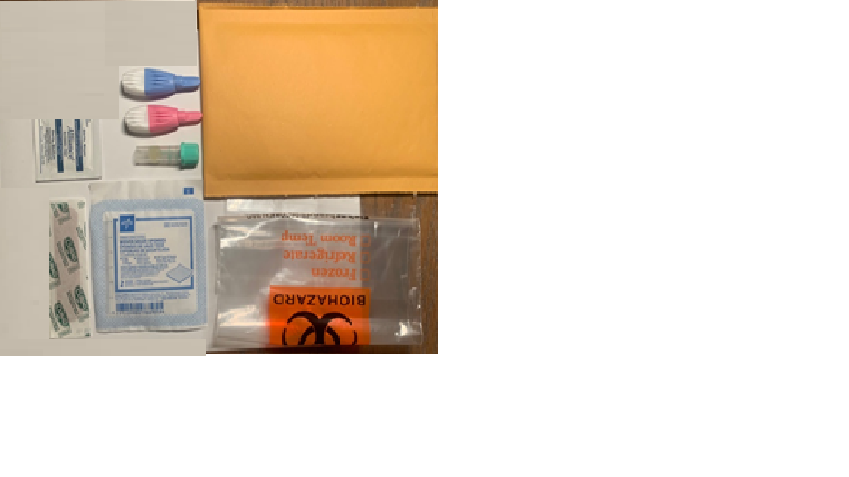

**Instructions:**

1. First, please review a short video on the website titled “How to take your COVID-19 capillary blood sample”

(<https://play.library.utoronto.ca/play/47916e103c26fd5d471cf9dd40ac26dd>) about self-collection of blood samples. Also see a pictorial view of the collection steps at the end of the document.

1. Read all the instructions for capillary (finger prick) blood sample collection. **If you need additional support with sample collection or will like to have your blood sample taken in a lab, please email the Study Coordinator at** [**uoftpandemicstudy.dlsph@utoronto.ca**](mailto:uoftpandemicstudy.dlsph@utoronto.ca)**.** You will subsequently receive information about how to make a blood collection appointment at a Lifelabs location near you.
2. To ensure the integrity of the blood sample and delivery to the laboratories on the day of collection, please collect blood specimens on **Mondays through Thursdays, avoiding any weekends and statutory holidays. Please refer to the schedule on the last page of this document for the days and times for dropbox collection at the different locations.**
3. Ensure that the sample ID on the tube matches the label on the requisition form.
4. Ensure your kit has all the items listed above and set it on a clean desk or table.
5. To facilitate collection, increase your heart rate by doing some exercise (e.g. going up the stairs) and activate the circulation in your hands by shaking them below your heart level and flexing your fingers.
6. Wash your hands with soap and warm water (the warm temperature will facilitate the blood collection). Dry your hands. You can also rub your hands together to warm them up.
7. At your collection station, keep your hand below the level of your heart. Disinfect your middle or ring finger (non-dominant hand) with the alcohol pad.
8. In the collection kit, we provide the pink lancets (default choice) that enable a medium flow. Alternative lancets (blue lancets) are available to those who need or prefer them. The blue lancets also have a retractable blade that has an increased puncture depth, resulting in a higher blood flow (please note that they may also be more painful to use).
9. Remove the cap from the lancet and press firmly against your finger. Aim to be close to, but not at the tip, and slightly off-center (see the pictures at the end of this document. The lancet is pressure activated; it will pierce the skin at a fixed depth and then the blade will retract, and you can begin your collection.
10. Use a piece of gauze to wipe away the first drop of blood.
11. Hold your finger over the tube and massage down from the palm to the tip of the finger to promote blood flow

to fill the tube to the 400-600μl mark (see image). If you are unable to get up to 400μl after the 1st attempt,

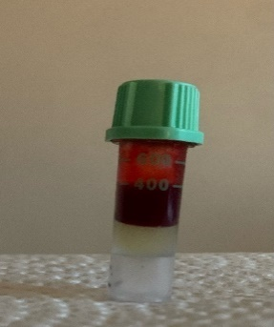repeat the blood collection using the 2nd lancet. **400uL** is needed to run the antibody tests. Less volume may

mean an inability for us to run the assay.

1. Replace the cap by twisting and pushing the cap downward until a snap is heard.
2. Immediately after collection, mix the sample by gently inverting the filled tube 5 to 10 times.
3. Place the tube in the biohazard bag.

Fold and insert the requisition form that you received into the biohazard bag. Please do not complete the requisition

form, or include any personal information in the package that will 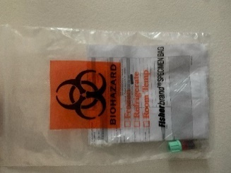be sent to the lab.

1. Seal the biohazard bag.
2. Discard both lancets in a separate sealable bag or hard container such as a resealable bottle and place in the garbage. **Samples sent with lancets will be rejected by the lab.**
3. Insert the biohazard bag into the return envelope. Seal the envelope.
4. Sample collection will commence on **Monday,** **13th September, and will go on till Thursday, 30th September 2021.**
5. You can continue to participate in the study after receiving the COVID-19 vaccine.
6. You will receive a **3rd $20 Uber eats gift card when you send in your 2nd blood sample** **and** **complete the associated questionnaires.**
7. If you were not able to send in a sample in the 1st and 2nd rounds of sample collection, you can still send in a sample in this 3rd round of collection, fill in the questionnaires, and be eligible to receive the $20 Uber eats gift card.
8. Please do not attempt to send your sample directly to the lab at Mt. Sinai Hospital.
9. If a drop box is located at your hall of residence, please drop your sample in the drop box between **10am and 1pm** on the day that you collect your sample.
10. If there is no drop box in your hall of residence, or you live in an off-campus location, please drop your sample off at the **Gerstein Library**.
11. If you **live in or around the GTA** and you are not able to drop your sample at the Gerstein library, **please call the courier** on **416-398-5155** on the day before you collect your sample to schedule a pickup. Please let them know that you are from the UofT Student Cohort Pandemic Study. Before the courier arrives, you can store the sample in a fridge.
12. If you plan to go to any of the UofT campuses in the Fall, you **must be** fully vaccinated against COVID-19, and it is required that you upload your proof of vaccination through UCheck (<https://ucheck.utoronto.ca/>).

If you are not fully vaccinated, please **do not** goon Campusto drop off your sample. Kindly call the Courier to pick up your sample. Please visit <https://www.utoronto.ca/utogether/vaccines> for more information about UofT vaccination requirements.

Extra consideration for home pickup

* + 1. Ensure that the requisition form is folded inside the biohazard bag with your sample.
    2. Do not place lancets in the biohazard bags. Discard them as directed above.
    3. Do not collect or send your sample on a Friday or the weekend.

1. If you have not received a kit for your 3rd sample, it should arrive in the next few days.
2. If you travelled or are no longer living within the GTA, and have no plans to return to campus before the the 3rdsample collection ends, or you have any questions or concerns, please contact the study coordinator at [uoftpandemicstudy.dlsph@utoronto.ca](mailto:uoftpandemicstudy.dlsph@utoronto.ca)

Please note capillary blood collection is associated with minimal risk, including pain at the site of collection bleeding, or scarring. Rarely, a person can also feel dizzy or faint after capillary blood collection. Pain at the site of collection can be relieved with cold compress. Bleeding can be stopped by application of pressure to the blood collection site with a gauze and band aid. Venipuncture at a laboratory is an option for those unwilling or unable to self-collect a capillary blood sample. If bleeding is slow to stop, apply pressure to the puncture site with a sterile gauze or a cotton ball. If bleeding continues after 3 to 5 minutes of applying pressure, consult a physician. Hydration with fluids can help a person who feels dizzy. If the participant has concerns, you may contact Health & Wellness (214 College Street, 2nd Floor Phone: 416-978-8030) during business hours, Telehealth at 1-866-797-0000, or visit an urgent care center or walk-in clinic for immediate attention. These events should subsequently be reported to the study coordinator at [UofTpandemicstudy.dlsph@utoronto.ca](mailto:UofTpandemicstudy.dlsph@utoronto.ca)

The blood collected will be used only for research. The data obtained from this study will help researchers better understand the COVID-19 virus and can also provide information that is useful for planning.

The information that we collect from this research study will be kept private and your identity will not be revealed in any dissemination of study results. Your individual data will not be shared to anyone outside of the research team. Only the research coordinator will be able to see your name. Your contact information will be collected to enable us follow up with you in the context of this study and to conduct contact tracing if you get exposed to COVID-19 in coming to the drop-off location sites. Contact information will however be kept separate from data collected through the research study to maintain anonymized research data. UofT will only have access to summary data of the entire cohort combined. Your participation in this study is voluntary, and you may withdraw and ask to have your survey data deleted by notifying the study coordinator at [UofTpandemicstudy.dlsph@utoronto.ca](mailto:UofTpandemicstudy.dlsph@utoronto.ca). There will be no penalty or loss of benefits to which you are otherwise entitled.

This study will have no direct cost to you and requires minimal time. You will receive a $20 Uber Eats gift card as a token of appreciation for participating in this study for each of the three data collections (online surveys and blood sample completed) for a total of $60.

If you have any questions about your rights as a research participant or have concerns about this study, please contact the Research Oversight and Compliance Office – Human Research Ethics Program, University of Toronto at [ethics.review@utoronto.ca](mailto:ethics.review@utoronto.ca) or 416-946-3273.  If you have any questions about the study, please contact the Research Coordinator at [UofTpandemicstudy.dlsph@utoronto.ca](mailto:UofTpandemicstudy.dlsph@utoronto.ca).

Thank you very much for your participation.

**Pictorial Instructions for blood sample collection**

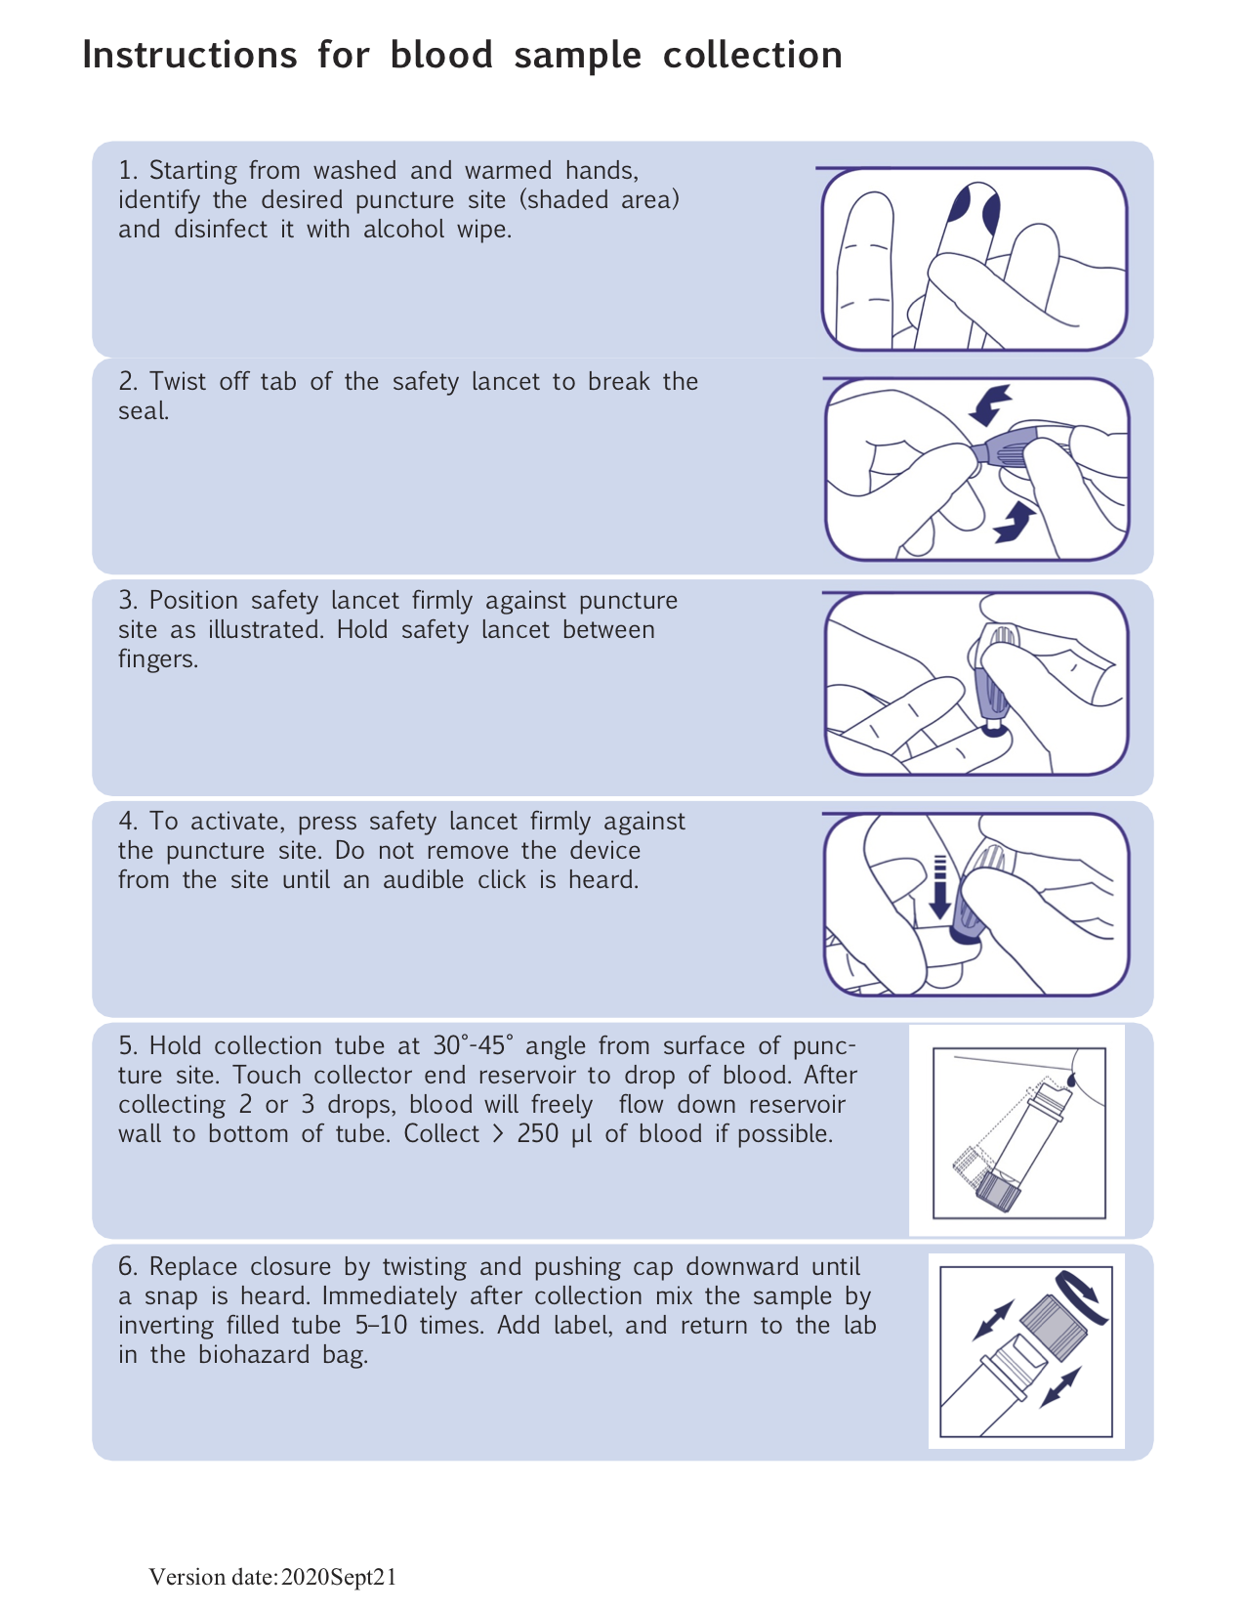

**Check list for blood sample submission**

|  |  |  |
| --- | --- | --- |
| 1 | I have verified the collection schedule on campus or made alternate arrangements through the study coordinator |  |
| 2 | I have collected my blood sample as instructed, and the cap is securely tightened. |  |
| 3 | The ID on my label is clearly visible and matches the number on the requisition form.  If not, I have relabelled my sample bottle with a permanent marker or paper label |  |
| 4 | I have included my requisition form in the return envelope |  |
| 5 | I have not written any identifying information on the requisition form |  |
| 6 | I was able to collect a minimum volume of 400uL. Insufficient volume may mean no result would be available for one or both antibody tests. |  |

**Sample Drop off Schedule**

Please collect your blood sample on the same morning as assigned for your residence or Gerstein Library, and drop off the sample at designated boxes at the following locations between **10am-1pm ONLY** from **September 13th-September 30th 2021.**

“**X**” indicates that samples will be collected on the marked day.

|  |  |  |  |  |  |  |  |
| --- | --- | --- | --- | --- | --- | --- | --- |
|  | **Drop off Location** | **Address** | **Students drop off time** | **Monday**  **Sept 13,20,27** | **Tuesday**  **Sept 14, 21, 28** | **Wednesday**  **Sept 15, 22, 29** | **Thursday**  **Sept 16, 23,30** |
| New College | Wilson Hall Front Desk | 40 Willcocks St. M5S 1C6 | 10am-1pm |  | X | X |  |
| Innis College | Innis College Front Desk | 111 St. George Street, ON M5S 2E8 | 10am-1pm |  | X | X |  |
| Woodsworth College | Woodsworth Residence Front Desk | 321 Bloor St W, Toronto, ON M5S 1S5 | 10am-1pm | X | X |  |  |
| University College | Morrison Hall Residence Desk | 75 St George St, Toronto, ON M5S 2E5 | 10am-1pm | X | X |  |  |
| Graduate House | Front desk | 60 Harbord St, Toronto, ON M5S 3L1 | 10am-1pm |  |  | X | X |
| Trinity College | Residence Welcome Desk | 6 Hoskin Avenue, Toronto, Ontario, Canada M5S 1H8 | 10am-1pm | X |  |  | X |
| St. Michael’s College | Porter's desk at Elmsley Hall | 81 St Mary St, Toronto, ON M5S 1J4 | 10am-1pm |  |  | X | X |
| Family House | Residence front desk | 35 Charles Street West Toronto ON M4Y 1R6 | 10am-1pm |  |  | X | X |
| Other students | Gerstein Library front desk | 9 King's College Circle, Toronto, ON, M5S 1A5 | 10am-1pm | X | X | X | X |
| UTM | NO DROP BOX AT UTM | | Participants in UTM should please call the Courier to make sample pick up arrangements. | | | | |